Fitting a lifestyle data model on raven score:

**Output:**

Raven Score:

Simply excluding NAs yields the following boxplot

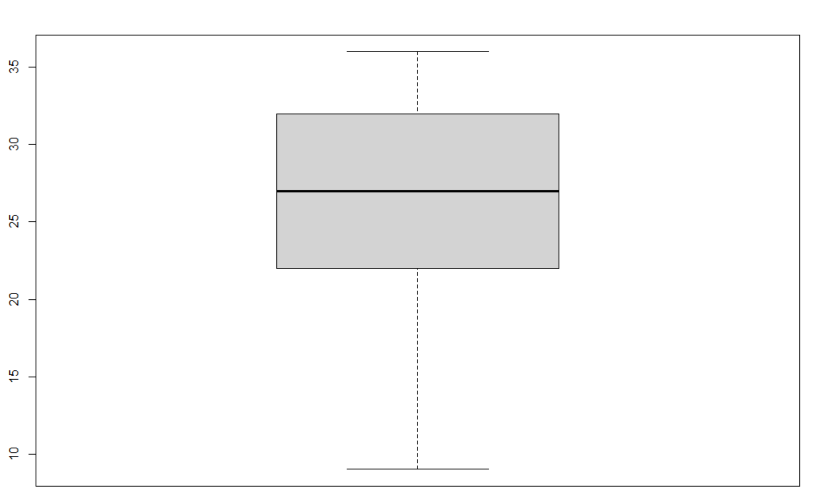

**Covariates:**

* Only using covariates falling under the lifestyle family in the codebook
* **Numerical:**

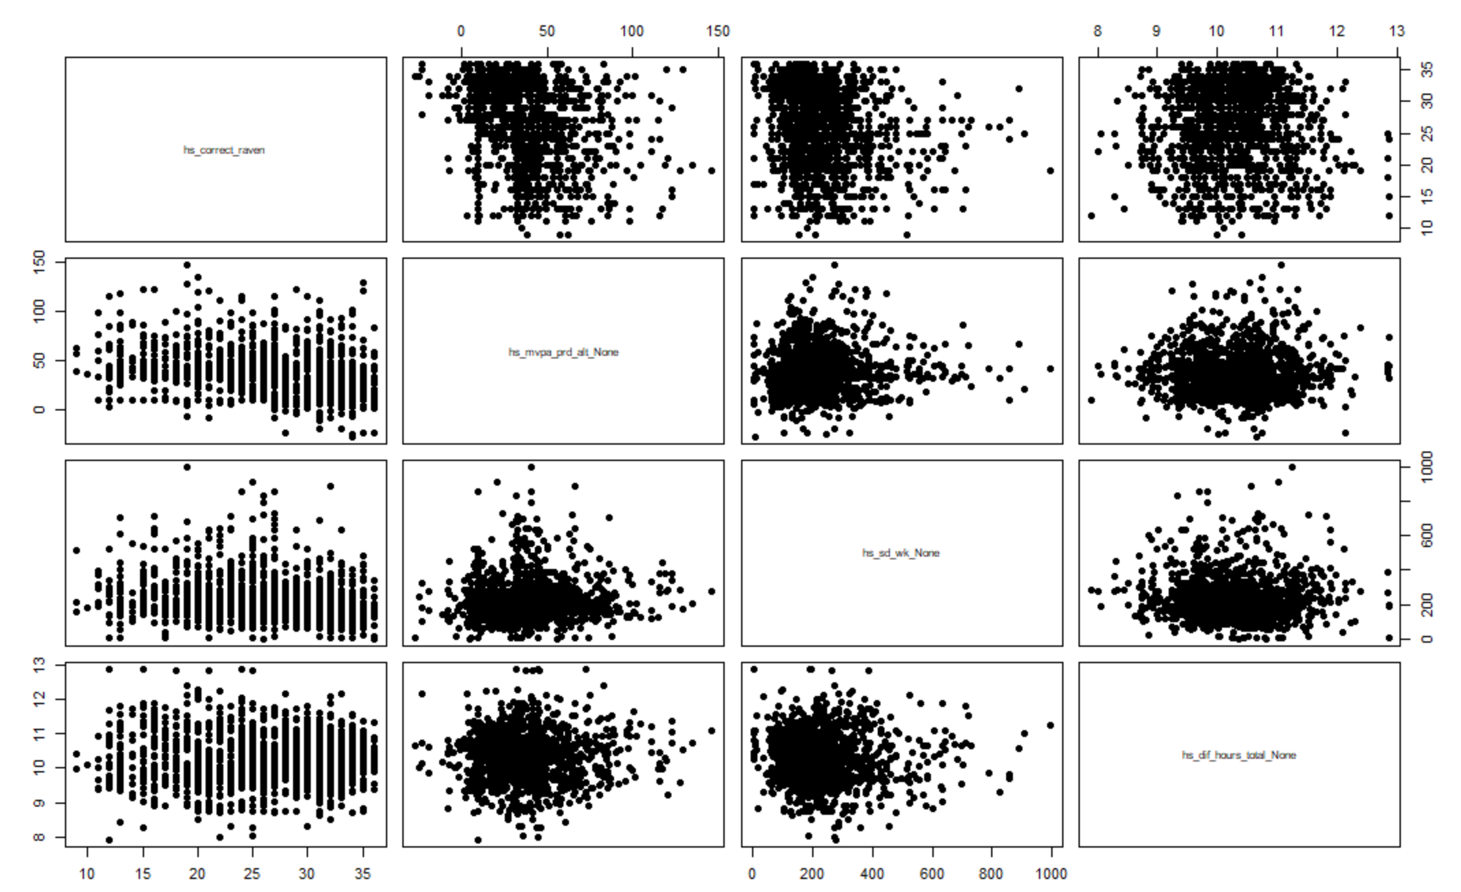

* *Hs_mvpa_alt_None: Clean & Over-reporting of Moderate-to-Vigorous Physical Activity (min/day)*

In relation to raven score, the scatterplot doesn’t seem to have any notable pattern that isn’t already caused by the discrete value of raven score or the range of hs_mvpa_prd_alt_none.

It’s values seem to tend to the 20 – 60 range, which is also seen in this boxplot.

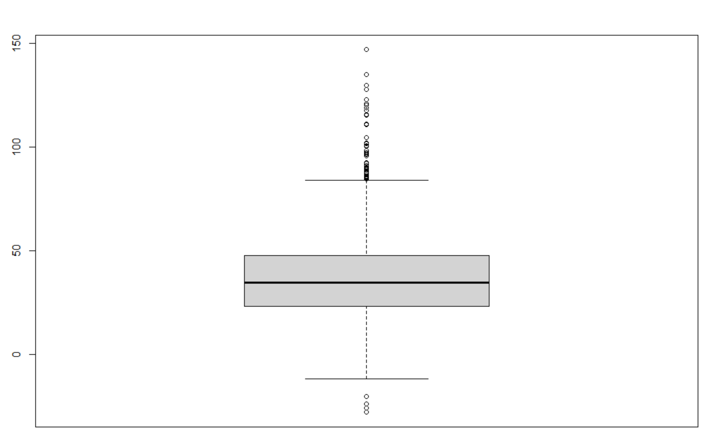

It seems that hs_mvpa_prd_alt_none and hs_sd_week_None has no prominent correlation except the clustering of points at the bottom, however there’s no pattern between both values and the IQR hs_sd_week_None

hs_mvpa_prd_alt_none and hs_df_hours_none seem perfectly random

* *Hs_sd_wk_None: sedentary behaviour (min/day)*

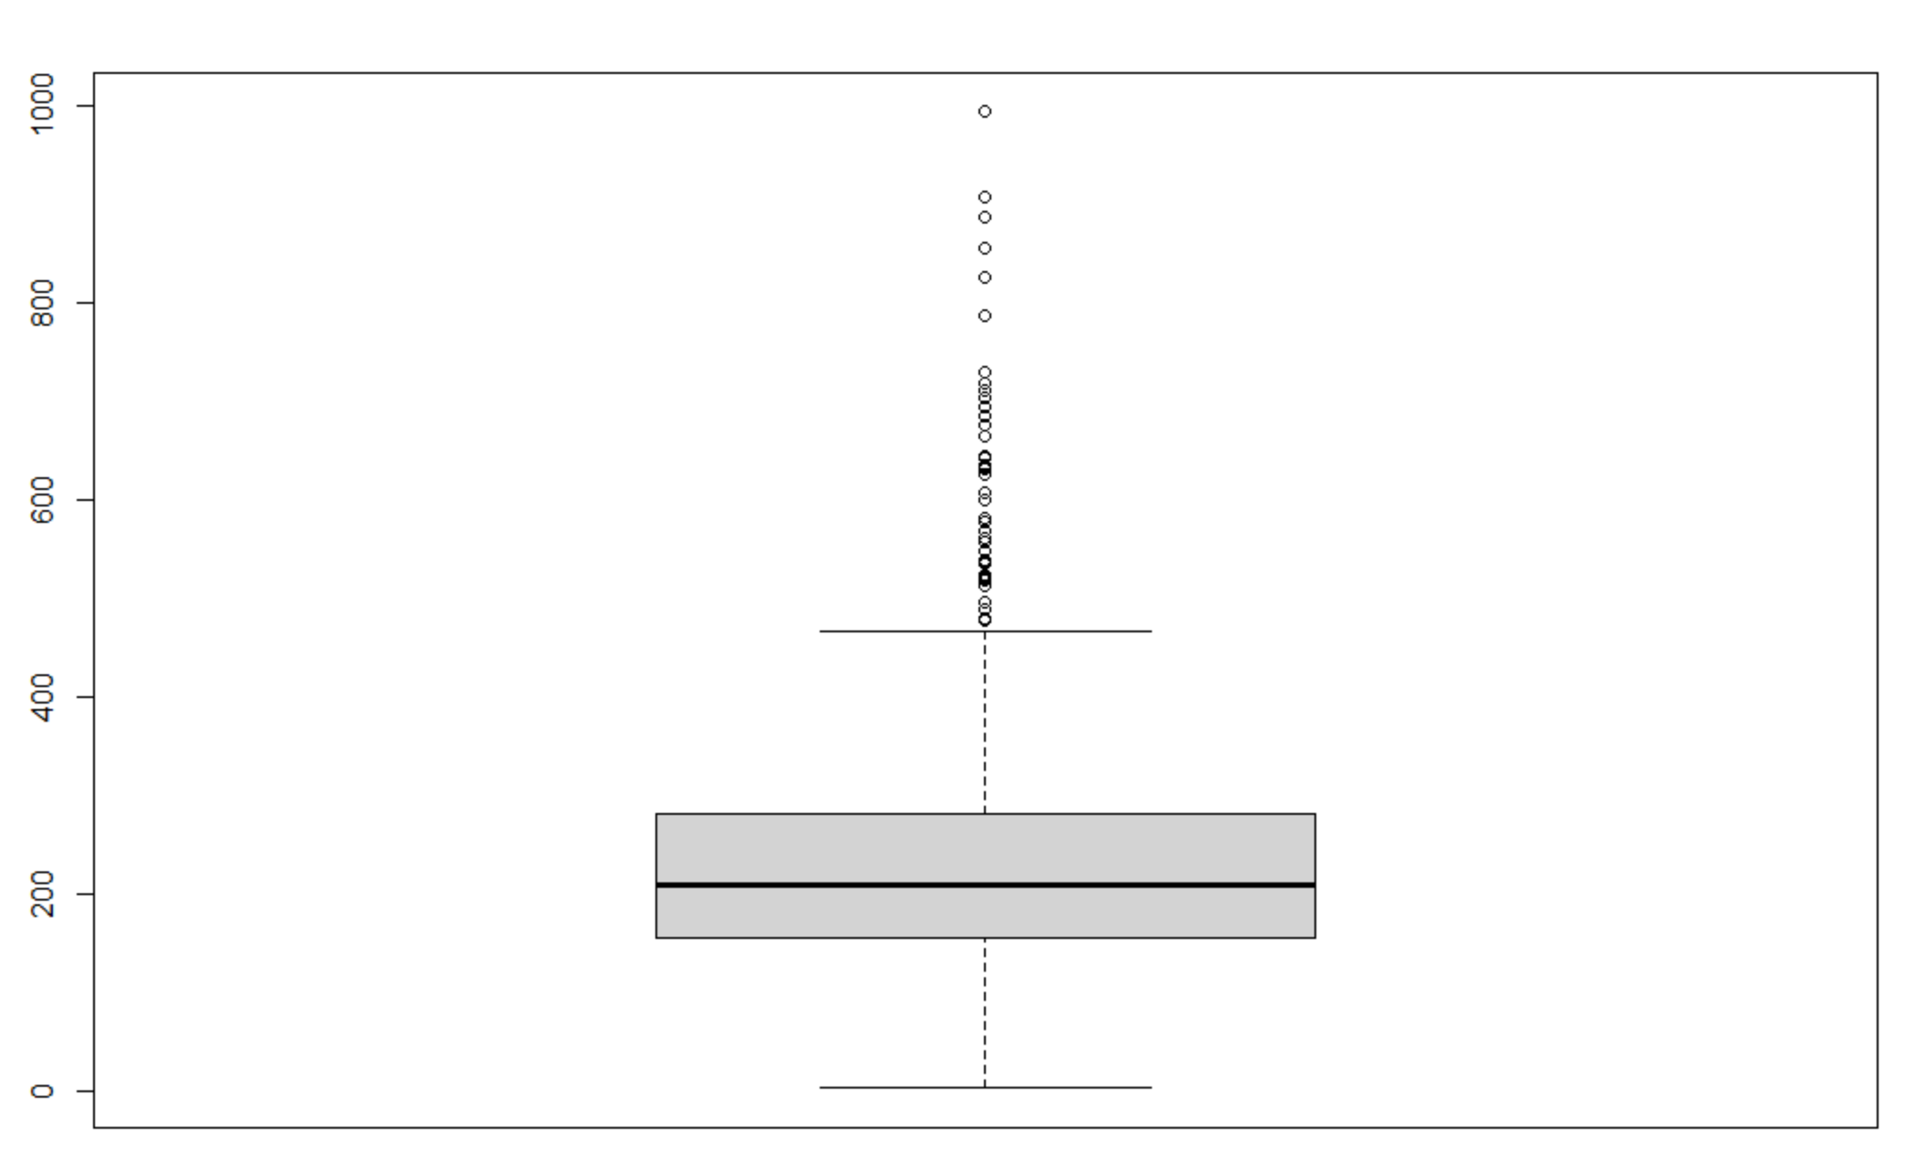

It’s scatterplot with raven score looks very clustered to the left half which is understandable since the sedentary behaviour tends to have lower values.

This applies to its scatterplot with all the other covariates too.

No particular pattern seen between sedentary behaviour and the other numerical covariates.

* *Hs_dif_hours_total_None: Total hours of sleep (mean weekdays and night)*

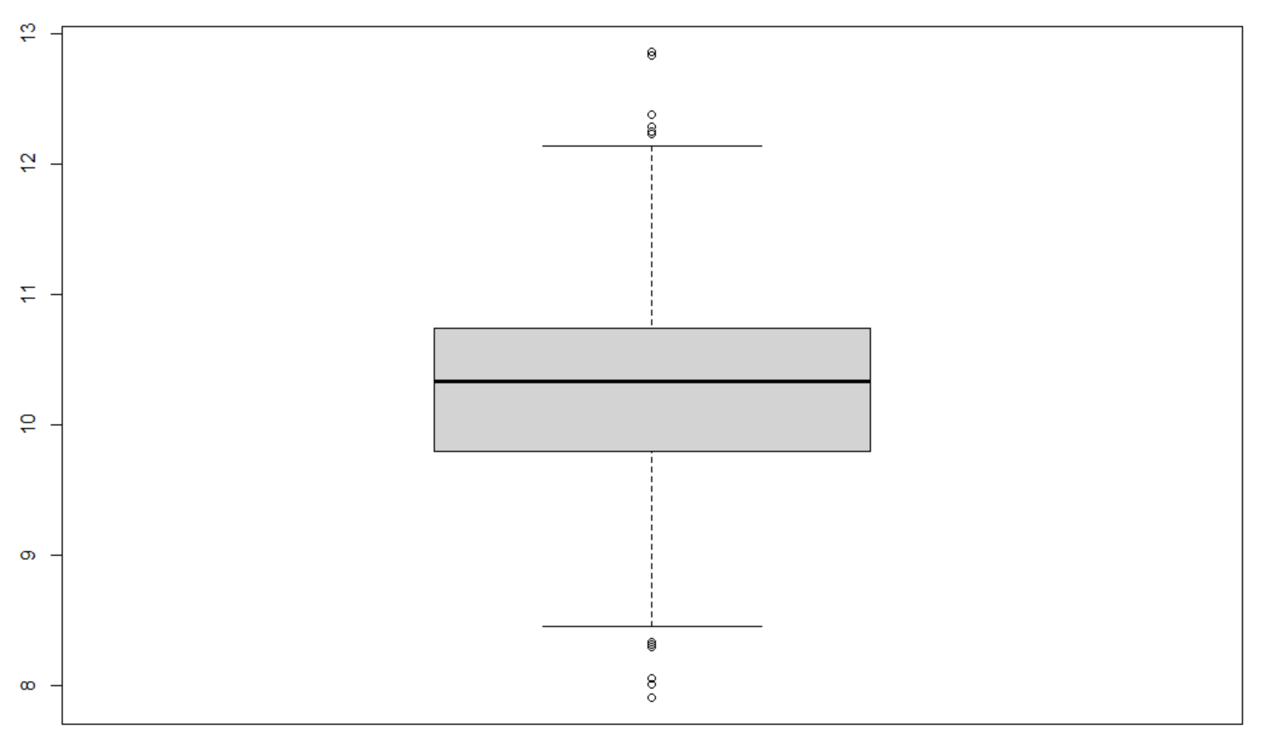

* **Categorical:**

